Exercise: 10

Draw a use case diagram for Library Management System is an automation system used to manage a library and the different resource management required in it like

cataloguing of books, allowing check out and return of books, invoicing, user

management, etc. The user can search for books details using few book properties

(Book ID, Title, Author, and Publisher). Searching should return details about all the

book copies that match the search query.

Aim:

To design a UML Use Case Diagram for a Library Management System that automates library operations such as cataloging books, searching, borrowing, returning, invoicing, and user management.

Procedure:

Step 1: Identify Key Actors

Librarian

Manages books and users.

Handles book check-out and return.

Processes invoices and fines.

Member (Library User)

Searches for books.

Borrows and returns books.

Views loan status and dues.

Library System (Automated Process)

Manages book catalog and copies.

Tracks borrowing and returning of books.

Generates invoices and fines.

Step 2: Define Use Cases for Each Actor

For Library Member:

Search Books – Search books using Book ID, Title, Author, Publisher.

Borrow Book – Request to check out a book.

Return Book – Return a borrowed book.

View Loan Status – Check borrowed books and due dates.

For Librarian:

5. Manage Books – Add, update, or remove books from the catalog.

6. Check-Out Book – Process a book loan for a member.

7. Check-In Book – Register a returned book.

8. Generate Invoice/Fine – Charge fines for overdue books.

9. Manage Users – Add or update library users.

For Library System (Automated):

10. Track Borrowing Records – Maintain records of issued books.

11. Maintain Book Copies – Keep track of available copies of books.

Step 3: Establish Relationships Between Use Cases

"Search Books" is used by Library Member.

"Borrow Book" includes "Check-Out Book", which is performed by the Librarian.

"Return Book" includes "Check-In Book", performed by the Librarian.

"Generate Invoice/Fine" is triggered when a book is returned late.

"Manage Books" and "Manage Users" are handled by the Librarian.

Step 4: UML Use Case Diagram Components

Actors: Librarian, Member, Library System.

Use Cases: Search Books, Borrow Book, Return Book, Check-Out Book, Check-In Book, Generate Invoice, Manage Books, Manage Users, Maintain Book Copies.

Relationships:

Includes: "Borrow Book" → "Check-Out Book", "Return Book" → "Check-In Book".

Extends: "Return Book" → "Generate Invoice/Fine" (if overdue).

Output:

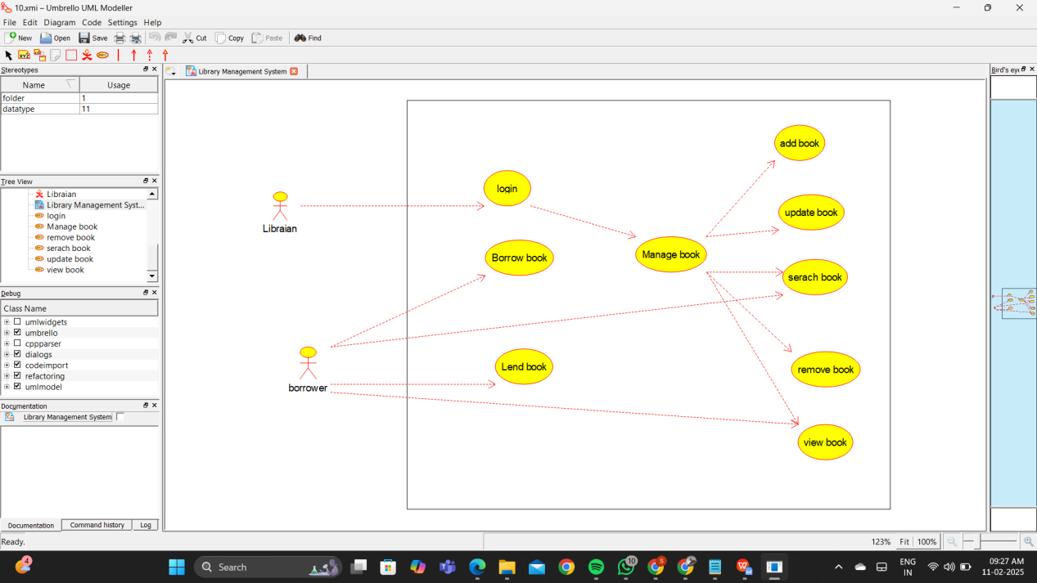

Result:

Thus the UML diagram has been implemented successfully.